Sexual Assault Follow Up (Optional)

- Indications
- Patients who have had a sexual assault, do not have acute injury, and have been referred for follow-up.
- Patients who have experienced a sexual assault and refuse transportation to the hospital or other follow-up resources but consented to CP follow-up.

*NOTE: Providing a follow up care does not preclude other treatment protocols nor the need for transportation to an emergency department. Oxygenation, ventilation, and treatment of injury are the primary goals of treatment. Transport to a specialty facility or follow up with specialty care is preferred.

- Procedure
- Assess patient and treat according to Patient Assessment and other indicated protocols (if any).
- Be sensitive to the patient’s emotional state. Protecting the patient’s privacy and respecting the patient’s beliefs regarding emergency contraception must be prioritized.
- Medications should be offered to appropriate patients who do not have other contraindications. The offer must include an objective explanation of the benefits and risks of use, as outlined in the medications being provided.
- For patients at risk of sexually transmitted infections, regardless of timeframe:
  - Administer ceftriaxone 500 mg IM
  - Administer doxycycline 100 mg AND facilitate prescription for 100 mg BID for 7 days
  - For male patients, administer metronidazole 2 g PO
  - For female patients:
    - Administer metronidazole 500 mg PO AND
    - Facilitate prescription for 500 mg PO BID for 7 days
  - Access patient’s vaccination status of HPV and Hepatitis B. If patient is not vaccinated, refer patient for vaccination.

- For patients whose assault was within 72 hours:
  - Evaluate for HIV risk
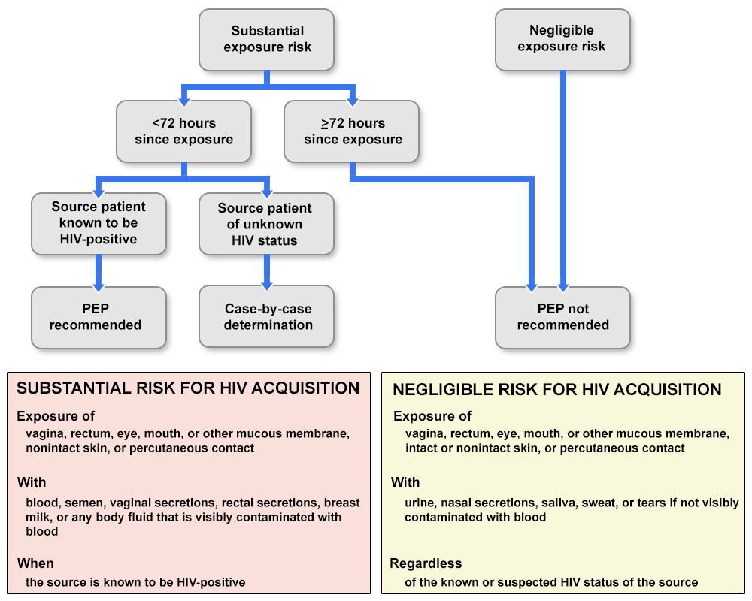

  - Advise patient of benefit of timely Post Exposure Prophylaxis (PEP) and follow up for 28-day prescription, along with referral to infectious disease clinic, if available.
- For patients at risk of pregnancy, within 3 days (72 hours) of assault
  - If the CP has a religious objection to emergency contraception, offer information on emergency contraception. If the patient requests access to emergency contraception, facilitate access to emergency contraception.
  - Otherwise, offer emergency contraception, including risks and complications
    - Provide fact sheet to patient
    - If patient consents, administer levonorgestrel 1.5 mg PO
    - Advise patient that efficacy is greatly reduced if there is vomiting within 2 hours of taking medicine, and they should follow up with a physician if this happens
- Document in Patient Care Record the education provided, medications administered, the patient’s if any declination occurs, and referrals or specific resources offered to the patient.
- Reiterate to the patient the need for follow-up care and remind of available resources, including:
- Sexual Assault Nurse Examiner or Sexual Assault Response Teams
- Any available literature for local resources

