This protocol is for trained CIP Paramedics only. If during assessment, procedure, or treatment the patient is found to have a medical emergency in need of hospital treatment, the CIP visit will be suspended, and local MCA protocols utilized.

Purpose: To provide additional guidelines beyond the CIP General Assessment and Care for evaluating, caring for and educating patients with wounds.

Aliases:

Follow CIP Patient General Assessment and Care protocol

Obtain additional vital signs, history, and diagnostics pertinent to condition and/or as ordered by physician which may include:

Vitals/physical assessment:

Categorize, stage and measure wound when applicable

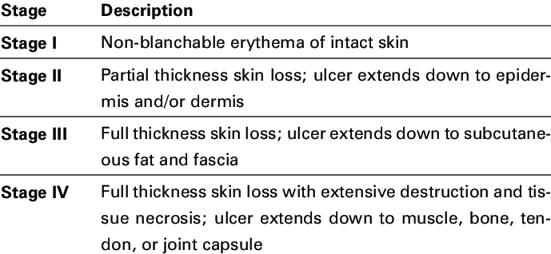

Location and extent of skin changes

Redness, drainage, weeping, ascending redness, warmth of skin, tract formation

Presence of pain

History:

Mechanism and duration of wound

On scene medication administration may include:

Use of approved MCA protocols and medications up to the extent of standard paramedic treatment according to protocol.

On-scene interventions may include:

☒ Suture Removal see CIP Suture Removal protocol (optional)

Decontamination and cleansing of wound

Wound closure utilizing wound closure strips

Wound dressing

On-scene education and suggested support sources may include:

Counsel/Educate

ADL precautions

Self-administered wound care

