This protocol is for trained CIP Paramedics only. If during assessment, procedure, or treatment the patient is found to have a medical emergency in need of hospital treatment, the CIP visit will be suspended, and local MCA protocols utilized.

Purpose: To provide additional guidelines beyond the CIP General Assessment and Care for evaluating, caring for and educating mothers and infants post- partum.

Follow CIP Patient General Assessment and Care protocol

Obtain additional vital signs, history, and diagnostics pertinent to condition and/or as ordered by physician which may include:

Vitals/physical assessment:

Mother

Blood pressure both manual and automated

Weight

Infant

Weight

Temperature

Heart Rate

Jaundice presence

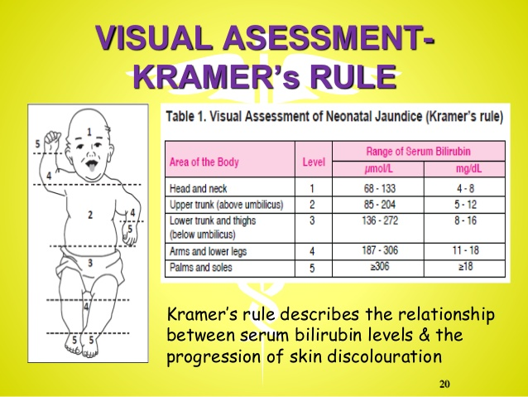

Adequacy of feeding

Wakefulness/waking to feed

Stool transition

History

Mother

Feelings of depression

Eating, sleeping and self-care

Complications with pregnancy

Infant

Feeding habits

Environment

Safe sleeping arrangement for infant

PEAT scale

Diagnostics:

Depression screening

Consider transport to the emergency department for the following:

Infant temperature > or equal to 100.4 degrees OR < 96 degrees Fahrenheit as taken rectally.

Infant HR > 200.

Infant current weight less than birth weight minus 10%.

Maternal hemorrhage (use of greater than one maxi pad per hour)

Maternal signs of anemia with or without signs of external hemorrhage

Maternal signs of eclampsia

On-scene medication administration may include:

Use of approved MCA protocols and medications up to the extent of standard paramedic treatment according to protocol.

On-scene education and suggested support sources may include:

Nutrition and supplements

Breastfeeding resources

Postpartum depression support

Newborn safety including:

Safe sleeping recommendations/resource

Car seat safety

Infant CPR

Shaken baby syndrome

